EECS332 Digital Image Analysis
MP3 – Mikhail Todes

My coding is done is c++. I complied it in a bash terminal using g++. I split it into two programs, histo.cpp and lightcorrection.cpp. The code I used to compile and create the executable was “g++ histo.cpp -o histo.e `pkg-config --cflags --libs opencv`”. I then ran the executable from the terminal using ./histo.e.

Each program only has one function. Histo.cpp has the fucntion:

Mat HistoEqualisation (Mat input);

And lightcorrection.cpp has the function:

Mat LightCorrection (Mat input);

The HistoEqualisation function firsts creates and populates an array called freq to store the frequency that each pixel value shows up. Each freq array element is then added the the probTot that is accumulated through the loop. This is multiplied by 255 and divided by the total number of pixels in the image to convert it to the right output value. Finally the new image output values are set.

The LightCorrection function uses the linear method. It first creates a structural element of 5x5 that has been normalised:
float SE [5][5] = {{1,2,3,2,1},
{2,3,4,3,2},
{3,4,5,4,3},
{2,3,4,3,2},
{1,2,3,2,1}};
This is all divided by 74 to normalise. This structural element is then run over each pixel and the new value is set.

IMAGES:

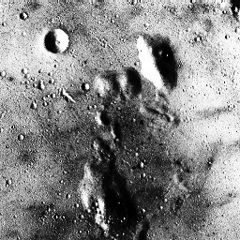Illustration 1: HistoEqualisation
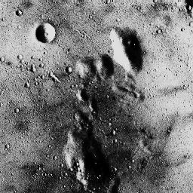Illustration 2: Light Corrected

